

POST-SURGICAL BREAST MASSAGE

Following breast surgery, and specifically breast augmentation with smooth-shell breast implants, it is important to maintain the soft feeling of your breasts.

Implants are a foreign substance. Your body will naturally respond to an implant by creating scar tissue or a capsule. This capsule can become excessive; the results may include:
- Reduced size of the implant pocket
- Restricted movement of the implant within the implant pocket
- An unnaturally firm feeling to the breasts
- A misshapen appearance to the breasts

Regular breast massage in the first 6 to 12 months following surgery can greatly reduce the potential for any of these conditions by manipulating your implants so that they can move freely within the implant pocket.

Breast massage can also retain the contour and symmetry of your breasts, or to gain breast symmetry where one implant may be slightly higher than the other.

When to perform breast massage
The following 4 exercises are the necessary steps to effective breast massage.

- Begin the exercises ( ) days after breast surgery. Perform the entire set of 4 exercises at 3 to 4 different times each day for the first 3 months following surgery. While this may be uncomfortable when you first begin to perform the exercises, it is very important that you begin these exercises early. The first days following surgery are the most critical period during which final adjustments can be made to the shape and contour of your breasts.

- After 3 months, if your breasts feel soft and implants are moving freely, you may perform your exercises 2 times per day.

- After 4 months and every day the first year, if your breasts feel soft and implants are moving freely, you may perform your exercises 1 time per day.

Should you experience any sharp pain, hot or flushed breast skin, severe tightening or hardness at any time with your breast implants, please consult our office as soon as possible.

How to perform breast massage

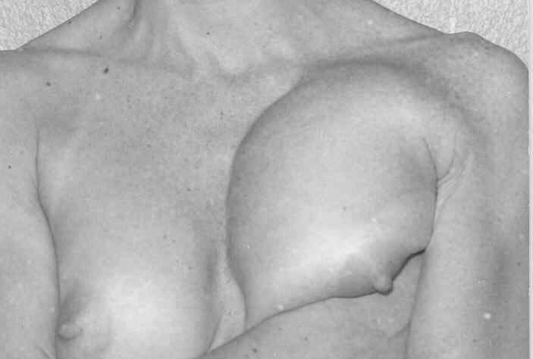
Step 1: Place your right hand under your left breast and squeeze the implant upward.
- Alternate with your left to right hand and “walk” the implant as high as you can within the implant pocket.
- When the implant reaches the top of the pocket, hold the implant in place for at least 30 seconds.
- Repeat beginning with your left hand under your right breast.

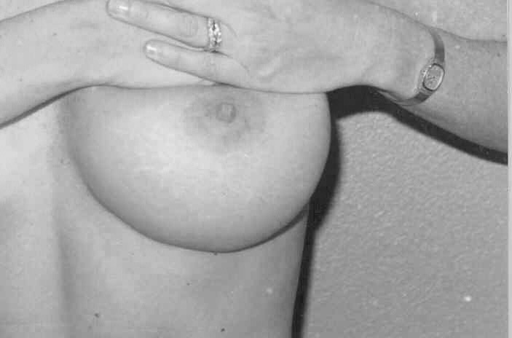
Step 2: Place your both hands on your left breast just above the nipple.
- Use steady gentle pressure to pull your breast tissue upward, while pushing the implant downward.
- Hold this position for at least 30 seconds.
- Repeat on your right breast.

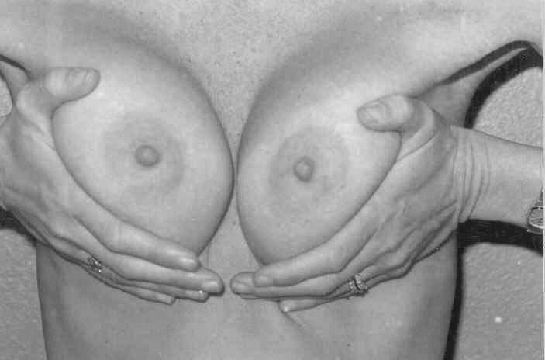
Step 3: Place your hands aside each of your breasts.
- Or, cross your arms and place your right hand at the outside of your left breast and your left hand at the outside of your right breast.
- Use gentle pressure to pull your implants to the center of your chest so that your breasts touch at the mid-line.
- Hold this position for at least 30 seconds.

